Induction machine exercise

# Introduction

This document contains instructions and assignments for the Induction Machine assignment. You should also use this document as a template for your report. Please state your answers in the textboxes provided and feel free to expand the textboxes as you please. You will have to submit this document on DTU Learn as pdf.

You will have 90 minutes in the laboratory for the experiments, including all preparation. Always consider the range of the measurement equipment and the accuracy of your measurements. Your report will reflect your learning and knowledge. Ensure that you are consistent in your report with significant digits, axis labels, units, etc. as these will affect your overall mark.

**SAFETY IS MOST IMPORTANT!!!!**

**You need to realise that you are operating with high power, rotating components and high voltages. Although the laboratory has been designed to be a safe workspace, your safety is your responsibility. If you are in doubt how to perform the measurements or suspect something might be unsafe, contact senior staff immediately.**

# Identification

Group number:

Group participants (names/ student numbers):

|  |  |  |  |
| --- | --- | --- | --- |
|  | Name | Student number | Percentage of contribution |
| Member 1 | Giovanni Maria Francesco La Scala | s2307081 | 100% |
| Member 2 |  |  |  |
| Member 3 |  |  |  |
| Member 4 |  |  |  |

# Experimental Setup

The experiments will be carried out in building 329 (Meeting place is atrium of the building 329a). There are three setups such that three groups can work in parallel. It is compulsory for all group members to attend the experiments. The time slot starts and ends sharp at the designated time in the timetable.

# Setup

The setup bench (fig. 1) has three phase supply (3 x 400V) which is fed through a HFI relay and a fused circuit breaker to a three-phase autotransformer (3 phase adjustable voltage source) **designated as 1** in the figure 1. The autotransformer has a maximal phase voltage of 230V.

The black lines indicate how the wiring in the cabinet is carried out. You are expected to complete the missing connections with extra banana cables, which are available in the lab. The protection element(s) must be part of your experimental circuit.

The voltage from autotransformer needs to be fed to the wattmeter (**indicated by 2** in the figure 1.) and before you connect the supply lines to induction machine which is indicated by number 4 in the figure (a for the diagram and b for the actual machine). Digital wattmeters (DIFFs) will be provided as alternative to ones indicated in Figure 1.

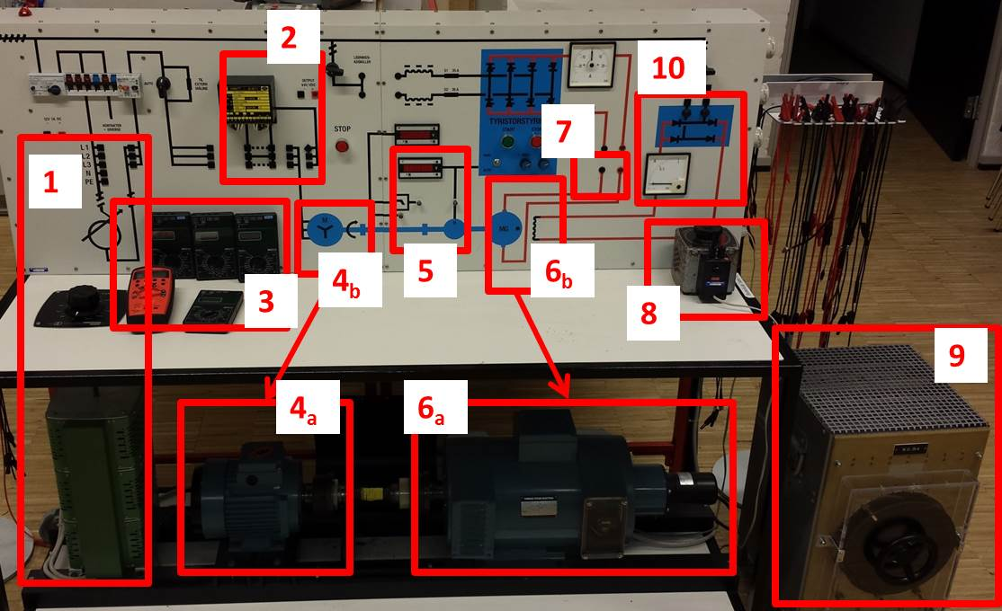

*Fig. 1 Experimental setup without connections*

You will be provided 2 multimeter in total.

Induction machine **(number 4b in the figure1)** and DC machine **(number 6 in the figure1)** are connected by a shaft. Speed of the shaft is measured by tacho-generator and is displayed in RPM. **The speed** is indicated on the front display **marked by number 5 in the figure 1**. In the case digital redout is not working, you will have a BNC connector you can use to measure DC voltage which is proportional to speed (constant is written on the board).

In addition, the value of the **shaft torque** between machines is also measured and displayed on the front display **marked by number 5 in the figure1**.

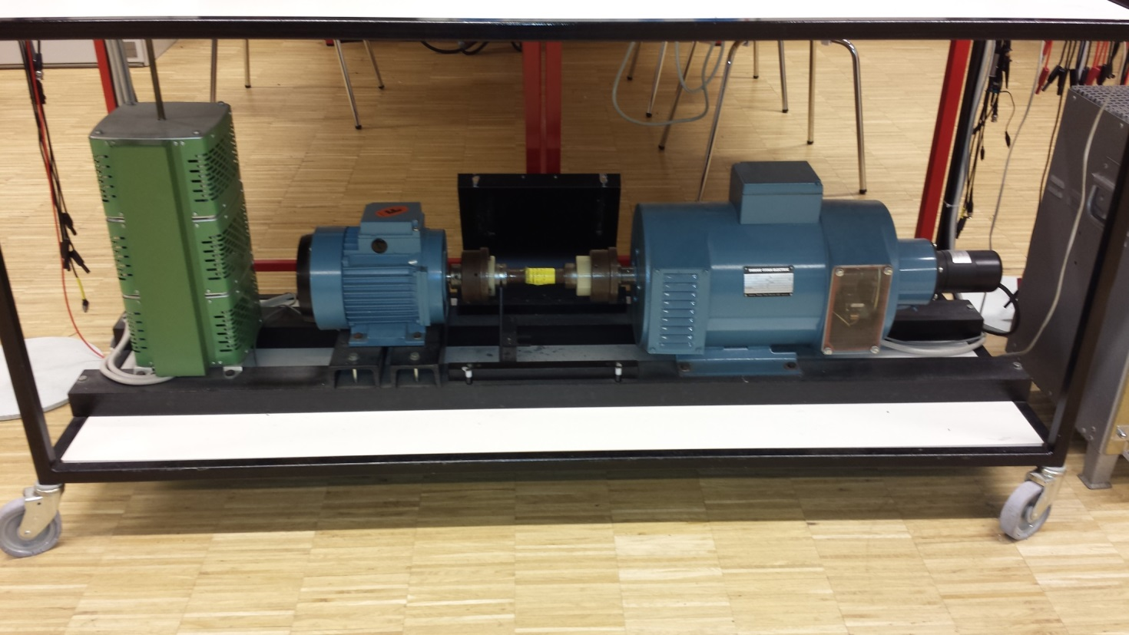

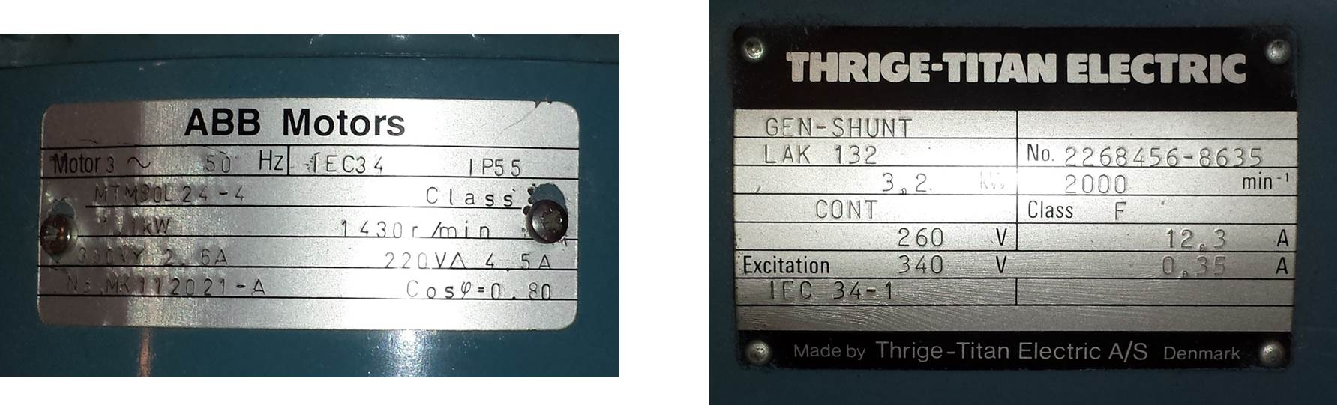Fig. 2 Machine test rig

DC generator is used to load the Induction motor. DE machine is electrically excited by a single phase auto-transformer **(number 8 in figure 1)**. Excitation circuit contains diode rectifier, as shown in circuit diagram and indicated by number 10 in the figure 1. DC machine **armature terminals** are accessible on the front **indicated by number 7 in figure 1**. **Load resistor**, i.e. the shunt, **number 9 in the figure 1**, is available for the experiments.

DC and induction machine name plates are shown in fig.2. As the power of DC machine is approximately two times higher than induction machine, the rated torques will be also mismatched. You are expected to account for this and other hardware limitations due to rated values during your experiments. You always need to be aware the ratings of all devices and use then in safe manner within the ratings.

# Tasks

The groups will have to connect the wiring and the measurement equipment corresponding to the requirements of experiment which is to be performed. Teacher of technician will be there to assist you. YOU MUST ASK FOR STUFF TO CHECK YOUR CONNECTIONS AND POWER UP THE SETUP BEFORE EACH EXPERIMENT!!!

Your task during the Laboratory exercise is to perform the experiments and collect the data for the set of experiments. The questions where you need to collect the data or not the behaviour of the machine are marked with yellow. Remaining questions, marked green, you should make sure you have noted all information to answer them but the answering process should be done **after** the Lab visit.

During your Lab Visit, you will do following experiments (estimate how much each test lasts):

* (5min) Phase resistance measurement for both Induction and DC machine: Sec.1. Here you will need to measure the phase resistance of induction motor using the multimeter.

* (15min) “No Load” test for the Induction Motor: Sec.2.
  + No load test for induction motor consists of supplying the induction motor with controllable 3phase terminal voltage (from Auto-transformer) while shaft is fee to spin. Measurements you should take are terminal voltage, phase current, active and reactive powers and shaft speed. You should start the experiment with nominal voltage and gradually reduce it while noting the measurements. You should end up with 10-15 terminal voltage values.
* (5min) Phase Sequence demo: Sec.4.
* (5min) Loss of Phase demo: Sec.5
* (10min) “Blocked Rotor” test for the Induction Motor: Sec.6
  + Blocked Rotor test for induction motor consists of supplying the induction motor with low controllable 3phase terminal voltage (from Auto-transformer) while shaft is restricted from spinning. Staff will demonstrate how to do achieve this. The terminal voltage is set (usually max10% of nominal value) so phase current in the machine is nominal. Measurements you should take are terminal voltage, phase current, active and reactive powers and shaft torque. You should start the experiment with nominal phase current and gradually reduce it while noting the measurements. You should end up with 5-10 sets of measurements.
* (15min) And the “Load” test for the Induction Motor for 2 terminal voltages: Sec.7
  + To perform Load - test for induction motor, you need to set constant 3phase terminal voltage (from Auto-transformer) and gradually increase the loading on the shaft while noting the measurements. The shaft load is controlled with DC machine, in particular you control the voltage of the field winding for DC machine and with it the load Induction motor sees. Measurements you should take are terminal voltage, phase current, active and reactive powers and shaft torque. You should record up to 5 sets of measurements for two values of terminal voltage, as specified in table.

Questions and Experiments

Q1. What are the power ratings of induction and DC machine? Please collect nameplate info for both machines and describe their meaning.

|  |
| --- |
| For the induction machine (ABB Motor) the power rating is given and is 1.1kW. Instead for the DC machine is not directly provided but it can be calculated using the rated voltage and current, rated voltage is equal to 260 V and rated current is equal to 12.3 A, then Power is P = V*I = 260 * 12.3 = 3198 W ≈ 3.2 kW. |

Q2. What is the speed range for both machines provided that they are excited with rated voltage value?

|  |
| --- |
| For the induction machine the rated speed is 1430 r/min (rotation per minute). For the DC Machine the rated speed is 2000 min-1 (rotation per minute). |

Q3. What is the number of poles of the induction machine: (Include derivation process as well)

|  |
| --- |
| The number of poles in an induction motor can be calculated using the formula: $n_{s}= \frac{120 f}{p}$ where **ns** is the synchronous speed, **f** is the frequency and **p** is the number of poles. Then solving for **p: $$p= \frac{120 f}{n_{s}}= \frac{120*50}{1430}=4.19 p= \frac{120 f}{n_{s}}= \frac{120*50}{1500}=4$$**  So, the induction motor has 4 poles. This is due to the fact that the rated speed should be 1500 r/min. |

Q4. Identify the type of the Induction (and DC machine). Describe where the rotor terminals of induction machine and DC machine are.

|  |
| --- |
| ABB Motors: the type of induction machine is squirrel cage induction motor, which is deduct because there are no rotor terminals accessible from outside.  THRIGE-TITAN Electric: This is a shunt-wound DC generator, indicated by “GEN-SHUNT” on the nameplate. |

Q5.Which machine is motor and which is generator in these tests?

|  |
| --- |
| The ABB Motors nameplate is from an induction motor, instead the THRIGE-TITAN Electric nameplate is from a generator “GEN-SHUNT”. So the Induction machine is the motor and the DC Machine is the generator in these tests. |

# Resistance Measurements

Estimate the average phase resistance of the Induction machine using resistance measurements at the terminals.

|  |  |
| --- | --- |
|  | Induction machine |
| RRS [Ω] | 11.4 |
| RST [Ω] | 11.4 |
| RTR [Ω] | 11.3 |
| Rph_average [Ω] | 11.367 |

RRS is the resistance between phase R and S. RST is the resistance between phase S and T. RTR is the resistance between phase T and R. Rph is the average phase resistance.

Estimate the average winding resistance of the DC machine using resistance measurements at the terminals. Compare precision of obtained results for resistance from multimeter and DC source.

|  |  |
| --- | --- |
|  | DC machine |
| Ra [Ω] | 1.7 |

Q6. How are the stator windings of induction machine connected?

|  |
| --- |
| The stator windings of the induction motor can be typically connected in either star (Y) or delta (Δ) configuration. Based on the nameplate information, the motor has a voltage rating of 380 V for star connection and a voltage rating of 220 for Delta connection. During these experiments the stator windings are star connected. |

Q7. Considering which material is most likely to be used for stator windings in machines, calculate in percentage how much the resistance would change if the winding temperature is increased from 20°C to 100°C during operation.

|  |
| --- |
|  |

Q8. The resistance measurements are carried out with DC signals. Discuss the validity of using DC measurements for AC analysis machines. Explain the reason why the AC resistance can be different from the DC measured resistance.

|  |
| --- |
| DC resistance measurements can be a good approximation for the AC resistance if the frequency is low enough that skin effect and proximity effect are negligible. However, at higher frequencies, AC resistance can differ from DC resistance due to several factors. Thus for accurate AC analysis, it is necessary to measure the impedance which include both resistance and reactance and not just the resistance. |

# Induction machine “No Load” Test

Record the No Load (NL) characteristic of the induction machine. You should record between 10 and 15 operating points.

|  |  |  |  |  |  |  |  |  |  |  |  |  |  |  |  |
| --- | --- | --- | --- | --- | --- | --- | --- | --- | --- | --- | --- | --- | --- | --- | --- |
| V1 [V] | 408 | 388.2 | 373.2 | 352.4 | 337.4 | 310 | 282.5 | 245 | 214 | 182.9 | 160.5 | 138.4 | 102.1 |  |  |
| I1 [A] | 1.7 | 1.58 | 1.5 | 1.37 | 1.3 | 1.17 | 1.04 | 0.89 | 0.78 | 0.69 | 0.63 | 0.59 | 0.59 |  |  |
| P1 [kW] | 0.4 | 0.38 | 0.36 | 0.33 | 0.31 | 0.28 | 0.25 | 0.23 | 0.2 | 0.18 | 0.17 | 0.16 | 0.15 |  |  |
| Q1 [kVAr] | 2.11 | 1.85 | 1.67 | 1.46 | 1.31 | 1.09 | 0.87 | 0.64 | 0.47 | 0.34 | 0.26 | 0.19 | 0.11 |  |  |
| N[RPM] | 1473.6 | 1473.6 | 1473.6 | 1470.3 | 1470.3 | 1470.3 | 1470.3 | 1466.96 | 1465.3 | 1460.2 | 1456.9 | 1450.3 | 1423.6 |  |  |
| T[NM] | -0.31 | -0.31 | -0.31 | -0.31 | -0.31 | -0.31 | -0.31 | -0.31 | -0.31 | -0.31 | -0.31 | -0.31 | -0.30 |  |  |
|  |  |  |  |  |  |  |  |  |  |  |  |  |  |  |  |

V1 is the line-to-line voltage at the supply side. I1 is the line current on the supply side. P1 is the three phase power at the supply side and N is the speed of the shaft.

Q9. List the conditions your experiment has been performed at. Discuss briefly the choice/ need for these particular conditions.

|  |
| --- |
| To retrieve the characteristic of the induction machine for the no load test, the DC machine has been disconnected as well as the load resistance in order to prevent interface.  The excitation is applied to the IM  The measurement instrument that were used are: Multimeter for voltage and current measurements (VMS), a wattmeter to read active and reactive power, Voltage at load side of IM which multiplied by a constant gives a velocity and finally torques readings. |

Q10. Present the No Load characteristic of induction machine:

|  |
| --- |
|  |

Q11. Is the characteristic linear or non-linear? Explain why this is so.

|  |
| --- |
|  |

Q12. How does power loss change during experiments? Explain why this is so. Present results also in a figure form.

|  |
| --- |
|  |

Q13. What is the efficiency of induction machine in this experiment? Explain why this is so.

|  |
| --- |
|  |

Q14. Is the rotor speed constant throughout experiments and is that important?

|  |
| --- |
|  |

Q15. How does the reactive power supply from auto transformer change throughout experiments?

|  |
| --- |
|  |

# Induction machine “phase sequence” Test

**Call a senior staff to help you with shaft cover.**

Induction machine is in No-load. Apply low three phase voltage to the stator windings (high enough so the shaft starts to rotate). Mark down the direction of rotation. Change the sequence of the supply phases and repeat the previous step. Mark down the direction of rotation.

|  |  |
| --- | --- |
| Initial Phase sequence | R- S- T |
| Rotation direction | Counter clockwise |
| New Phase sequence | R- T- S |
| Rotation direction | Clockwise |

Q16. Is there a difference between two cases? Explain and argue why this is so.

|  |
| --- |
| Yes, there is a difference between the two cases, and the change in the direction of rotation is expected and intentional. In a three-phase AC induction motor, the direction of rotation is determined by the sequence in which the phases are supplied to the motor’s stator windings. This sequence creates a rotating magnetic field which the rotor follows, thus determining the direction of the motor’s rotation.  When the phase sequence is **R-S-T** the rotation magnetic field moves in a direction that makes the rotor turn **clockwise**. Instead changing the sequence in **R-T-S** the rotation magnetic field reverse the direction, so this causes the rotor to move in the opposite direction, **counterclockwise**.  This behaviour is consistent with the right-hand rule of electromagnetism, where point the thumb off right hand in the direction of the magnetic field (from R to S to T) the fingers curl in the direction of current flow. By reversing the sequence, also the magnetic field’s direction reverses and consequently the direction of the rotor’s rotation. |

# Induction machine “loss of phase” Test

Induction machine is in No-load. Apply low three phase voltage to the stator windings. Voltage should be lower than rated but high enough to allow rotor to reach the no load or “idle” speed. Pull out one of the supply lines at induction machine terminals. Observe the machine operation.

|  |  |  |
| --- | --- | --- |
|  | Starting the IM with one phase disconnected | Disconnecting one phase after IM has reached no load speed |
| Observations | It did not start | Continuous rotating at no load speed, making a louder noise. |

Q17. What have you observed? How will three phase induction machine operate when one phase is lost?

|  |
| --- |
|  |

Q18. Describe previous experiment in terms of first principles and basics of machine operation. Explain your observation for experiment using same first principles.

|  |
| --- |
|  |

Q19. How will the induction machine operate if the rotor is at stand still and the voltage is supplied only to two phases (one is lost).

|  |
| --- |
|  |

Q20. Explain why.

|  |
| --- |
|  |

# Induction machine - Locked Rotor Test

**Call a senior staff to help you physically lock the rotor.**

Record the blocked rotor (BR) characteristic of the induction machine up to a line current of 5A with all devices included. You should record between 5 and 10 points. Take extra care to perform measurements above machine’s rated current quickly (5 sec max).

|  |  |  |  |  |  |  |  |  |  |  |
| --- | --- | --- | --- | --- | --- | --- | --- | --- | --- | --- |
| V1 [V] | 108 | 96.6 | 86.1 | 76.7 | 67.4 | 61.8 | 46 | 32.7 |  |  |
| I1 [A] | 3.6 | 3.2 | 2.8 | 2.5 | 2.2 | 2 | 1.5 | 1.1 |  |  |
| P1 [kW] | 0.8 | 0.6 | 0.5 | 0.4 | 0.3 | 0.25 | 0.14 | 0.07 |  |  |
| Q1 [kVAr] | 0.9 | 0.7 | 0.5 | 0.4 | 0.34 | 0.27 | 0.15 | 0.08 |  |  |
| T[NM] | -1.19 | -0.91 | -0.75 | -0.6 | -0.45 | -0.38 | -0.2 | -0.08 |  |  |
|  |  |  |  |  |  |  |  |  |  |  |
|  |  |  |  |  |  |  |  |  |  |  |

V1 is the line-to-line voltage at the supply side. I1 is the line current on the supply side. P1 is the three phase power at the supply side.

Q21. Plot the BLR characteristic for the induction machine

|  |
| --- |
|  |

Q22. Is the characteristic linear or non-linear? Explain why this is so.

|  |
| --- |
|  |

Q23. How does power loss change during experiments? Explain why this is so. Present results also in a figure form.

|  |
| --- |
|  |

# Induction machine under load - Test

Use the DC machine, connected to a shunt with variable resistance, to load the induction machine and perform the following experiments:

1. Stator voltage of the induction machine is at rated value and is constant during the experiment. Vary the braking torque on the shaft by changing the excitation of the DC machine.

Note: Shunt resistance should be at highest impedance setting

1. Repeat previous experiment with 85% of the rated supply voltage for induction machine.

Record induction machine quantities for approximately 6 values of DC machine excitation, adjusting the induction machine power to range from rated power down to a no load.

The load is 16 Ohms

|  |  |  |  |  |  |  |  |  |  |  |  |  |  |  |  |
| --- | --- | --- | --- | --- | --- | --- | --- | --- | --- | --- | --- | --- | --- | --- | --- |
|  | V1=100% Vrated | | | | | |  | V1=85% Vrated | | | | | | | |
| V1 [V] | 407 | 406 | 407 | 406 | 405 | 411 | 350 | 350 | 350 | 347 | 347 | 346 |  |  |
| I1 [A] | 1.7 | 1.7 | 1.7 | 2.2 | 2.7 | 3 | 1.3 | 1.4 | 1.8 | 2.6 | 2.8 | 3 |  |  |
| P1 [kW] | 0.4 | 0.5 | 0.8 | 1.9 | 2.7 | 3.1 | 0.3 | 0.5 | 1.4 | 2.4 | 2.6 | 2.9 |  |  |
| Q1 [kVar] | 2.1 | 2.1 | 2.1 | 2 | 2.1 | 2.3 | 1.4 | 1.4 | 1.4 | 1.5 | 1.6 | 1.7 |  |  |
| N[RPM] | 1470 | 1467 | 1462 | 1432 | 1409 | 1399 | 1469 | 1460 | 1432 | 1395 | 1384 | 1374 |  |  |
| T[Nm] | -0.31 | -0.72 | -1.5 | -5.4 | -8 | -9.3 | -0.3 | -1.05 | -3.89 | -7 | -7.7 | -8.4 |  |  |
| Va [V] | 18.6 | 30 | 52.3 | 104.6 | 128 | 137 | 18.5 | 40.3 | 87.9 | 118.3 | 123.5 | 129 |  |  |
| Ia [A] |  | 1.9 | 3.3 | 6.6 | 8 | 8.6 |  | 2.5 | 5.5 | 7.4 | 7.7 | 8.1 |  |  |
| If [A] | 0 | 0.01 | 0.05 | 0.1 | 0.15 | 0.2 | 0 | 0.05 | 0.1 | 0.15 | 0.17 | 0.2 |  |  |

Q24. Calculate the efficiency, torque and reactive power of induction machine for same noted operation points captured in the experiment.

|  |
| --- |
|  |

Q25. How the supply voltage affects the induction machine operation?

|  |
| --- |
|  |

Application

Estimate the equivalent circuit parameters of the test IM at rated conditions.

|  |  |  |  |  |  |
| --- | --- | --- | --- | --- | --- |
| R1 [Ω] | X1 [Ω] | RC [Ω] | Xm [Ω] | R’2 [Ω] | X’2 [Ω] |
|  |  |  |  |  |  |

R1 is the stator phase resistance. X1 is the stator phase leakage reactance. RC is the core loss resistance. Xm is the magnetising reactance. R’2 is the rotor resistance referred to the stator. X’2 is the stator phase leakage reactance referred to the stator side.

Q26. Plot the torque vs speed characteristic of the induction based on derived parameters and for speed range 25%-175% of synchronous speed. Include also experimental results from “Performance under load”.

|  |
| --- |
|  |

Q32. Derive and calculate the maximum electromagnetic torque and corresponding slip.

|  |
| --- |
| $$T_{max}= \frac{poles}{2πf_{e}}⋅\frac{0.5⋅n_{ph}⋅{V_{1,eq}}^{2}}{R_{1,eq}+\sqrt{{R_{1,eq}}^{2}+{(X_{1,eq}+X_{2})}^{2}}}$$ We already know all the parameters involved in the formula; we just need to express the Thevenin’s equivalent circuit quantities:   * We extract $R_{1,eq}$ from the real part of $Z_{1,eq}$, which is given by: $Z_{1,eq}= \frac{jX_{m}(R_{1}+jX_{1})}{R_{1}+j(X_{m}+X_{2})}≃(11.857 + i1.0838⋅{10}^{4})Ω⇒R_{1,eq}≃ 11.857 Ω$* We calculate the value for $V_{1,eq}$ as: $V_{1,eq}=V_{1}\frac{jX_{m}}{R_{1}+j(X_{m}+X_{1})}≃\left(2.4057⋅{10}^{2} + i2.1258⋅{10}^{-2}\right)V$  Substituting all the values in the equation we have: $$T_{max}≃$$ |
|  |

Q27. Is the magnetization inductance of induction machine, Xm , constant or will it vary with stator current? Why? Support you answer with the plot.

|  |
| --- |
| A graph with a line drawn on it  Description automatically generatedAs shown by the plot besides, the magnetization inductance $X_{m}$ seems to be decreasing linearly as the current increases. |

Q28. Is the leakage inductance of induction machine, X1 + X2, constant or will it vary with stator current? Why? Support you answer with the plot.

|  |
| --- |
| A graph with a line  Description automatically generated  For what concerns the leakage inductance of the IM, as the current increases, $X_{1}+X_{2}$ does not change significantly.  For this plot the data from the locked rotor test have been used, which allow us to evaluate: $$X_{1}+{X_{2}}^{'}={\frac{V_{1,locked}}{Q_{1,locked}}}^{2}$$ |

Q29 . Assuming the geometry of induction machine has stayed the same and the aluminium rotor bars have been replaced by a cupper bars, discuss implications this would have on the output power, efficiency, torque – speed characteristic and finally the cost per unit of torque of the machine. Illustrate the “new” torque – speed characteristic in the figure.

|  |
| --- |
|  |

Discussion

Feel free to discuss the laboratory exercise in more details in this section.

|  |
| --- |
|  |